Board President Report
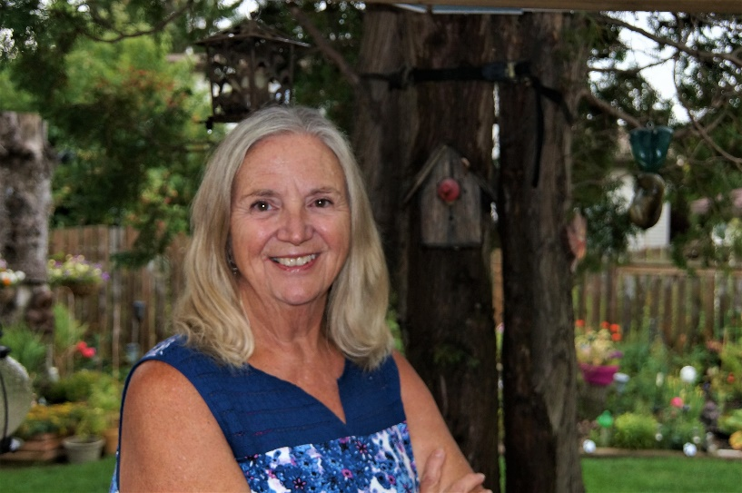
Sept 2020
Welcome finally, to the 2020 Annual meeting of the CMHA Saskatoon Branch. It is later than usual, and we did it after an especially difficult 6 months.
What an interesting and most challenging time we are living through at this moment. It seems that as soon as things appear to settle, new challenges arise. The sense of predictability and routine which has comforted us has changed dramatically and perhaps also created new opportunities.
As I am writing this report on my laptop, I am preparing for our Annual General Meeting which will be via ‘Zoom’. Over the last number of months our branch staff have creatively crafted and delivered services virtually. Educational events are also being delivered virtually and we are developing an online training platform that will expand content and allow more people access. We are looking forward to the development of the online CMHA Saskatoon Wellness Institute this upcoming year.
Personally, I have had the opportunity to take a class that I would not have been able to do in a classroom due to my schedule and work. I was able to participate as classes were offered virtually, so I could learn in my home. I am unable to visit my family in Manitoba and have not seen my aunt in long term care. My girlfriend, who is 99, and I speak on the telephone more often as I am unable to visit her. I can partially meet spiritual needs as some religious services are linked to Facebook. Our world has changed drastically and while maintaining important relationships remains critical, how we do so has also changed.
How many more people are we able to reach virtually that previously we could not, as they were isolated in their homes or living spaces. What about those who are unable to connect virtually or are not knowledgeable with technology? We are challenged to find new ways to connect and reach out to people. Yet, how we touch and show we care physically has been dramatically impacted. Our resilience has been challenged and congratulated, seemingly at the same time.
As I reflect on the many skills and advances, we currently have to work through this pandemic, I wonder what it may have been like in the past when these crises struck. Were folks in a similar place to us? The global reality we experience today gives us connection, but it also creates great risk. How we balance this reality will make all the difference as we experience the next months.
So, as I share personal thoughts, it is important to note how CMHA Saskatoon is working to meet our community needs. How we work within our capacity and prioritize urgent and changing needs remains critical. Our Executive Director Faith Bodnar’s report outlines where we have come from in the past year and introduces our future vision.

Many of our fundraising events have been cancelled or changed to meet public health and safety requirements. New opportunities have also come forward. We look forward to the Shoppers Drug Mart Run for Women September 17-27, 2020. This virtual event will bring hundreds of people together to run, walk and roll as they raise funds for CMHA Saskatoon.
World Suicide Prevention Day was September 10. I would like to offer appreciation to one of our volunteers, Marilyn Irwin, who creatively shared her grief journey following her son’s death by suicide. Marilyn’s artwork and words were presented on the front lawn of our office and shared with those driving by, those who stopped to chat and thousands more through extensive media coverage. 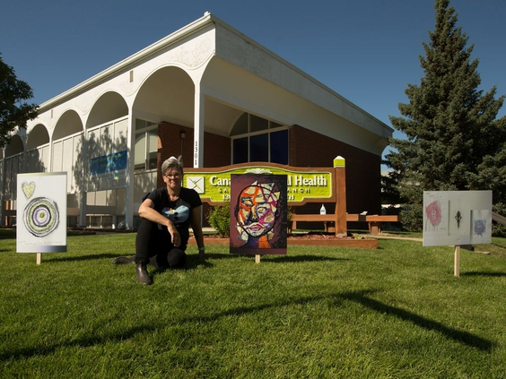
On behalf of the Board of Directors, we extend our appreciation to all our volunteers who have supported the branch as we grew through this new reality. Please know that each of you are vital and matter to us deeply.
On behalf of the Board of Directors I would like to extend our deepest appreciation and thanks to Joyce Meyer who has served on the board for the past 4 years, chairing and participating on committees. Joyce has brought vital ideas and innovative thinking and will be missed around our Board table. I look forward to her continuing involvement as a branch volunteer.
I welcome new Board members who will bring their knowledge and passion to our work.
Once again, I would like to highlight the value, creativity, resilience, and skill of our staff in meeting the challenges as we navigate our pandemic and create a ‘new’ normal for our branch. Each of you has brought immense skills and knowledge to your work and we appreciate you deeply. Thank you for the work you do.
As Board President I would like to extend my appreciation to our Board of Directors. We are a dedicated group of individuals who come together to support and serve this branch in the work we do. We have met frequently and even urgently on occasion and had much back and forth communication on how best to move forward during this pandemic time. Each board member has brought individual skills and ideas that have assisted our branch in navigating our new reality.
We welcome Margot Weiner, our Director of Development, who will assist us and guide us as we develop new fund-raising initiatives.
The financial support of our funders and donors during this past year has once again been critical to our ability to develop and deliver our programs to best meet the needs of our community. Financially, 2019/20 was a record year for us. While I know this year presents many challenges, I am confident we will rise to them and respond to the needs of our community.
Once again, on behalf of the Board of Directors, we know there is much work ahead for all of us in supporting the mission and vision of this organization. We take on this responsibility with passion and energy. I look forward to continued work with all our supporters, funders, staff and volunteers in creating our new normal, as we navigate through and emerge from this pandemic safely and mentally healthy.
“Be resilient, be safe, and above all know you matter…”
Teri Schroeder
CMHA Saskatoon Branch
Board President

